**CS202 Second Exam**

Due: 8:00 AM, 11/6/2017 Name: _Manwai Nguyen___ Score: _____________

1. (20%) Do Programming Exercises P5.20 on page 240.
   1. Write a method called “isLeapYear” to test if a year is a leap year or not.
   2. Then use the main method to call and pass year to the method above.
   3. The isLeapYear method returns true or false to main method.
   4. Finally, the main method print out the year is a leap year or not.
   5. Use the following five years to test your program.

1996, 2000, 2004, 2010, 2017.

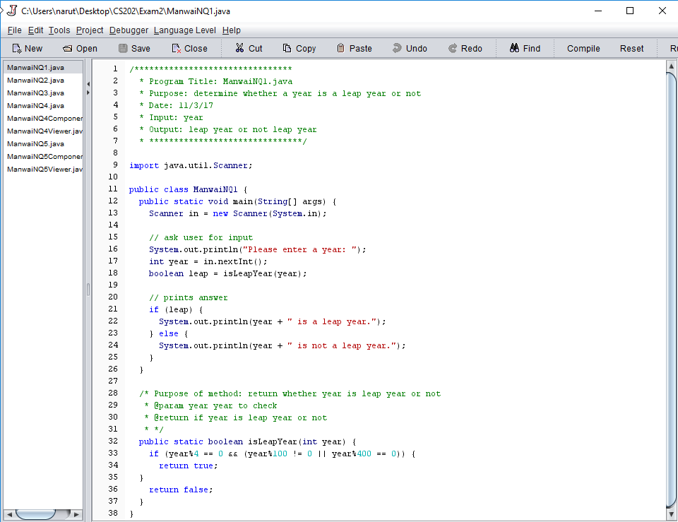

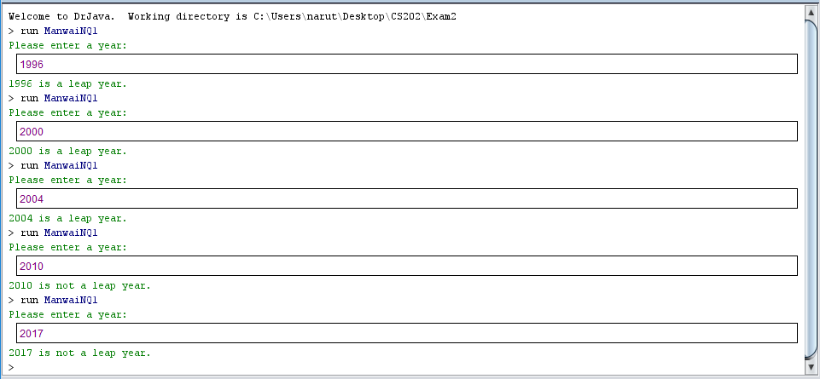

1. (20%) Do Programming Exercises P6.11 on page 308.

Write a method called “sameElements” to test if two arrays have the same elements in some order.

Then use the main method to call and pass two arrays to the method above.

The sameElements method returns true or false to main method.

Finally, the main method print out “identical” (if true) or “not identical” (if false) for the two arrays.

Use the four arrays in P6.11 to test your program.

// *One of the arrays are the same so I didn’t bother remaking it*

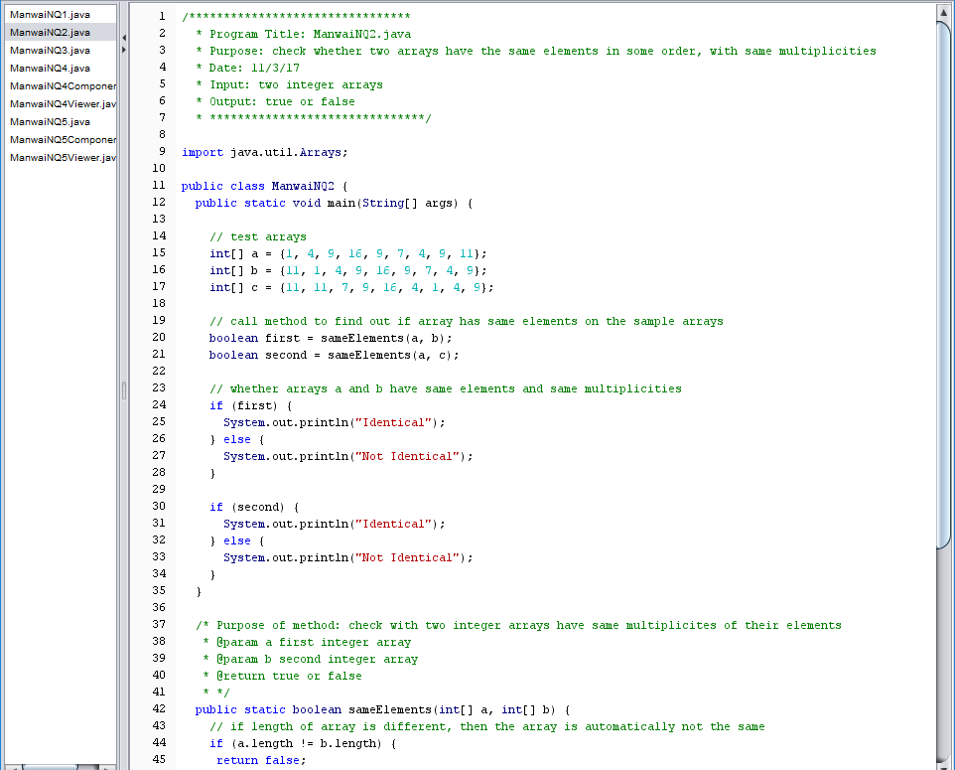

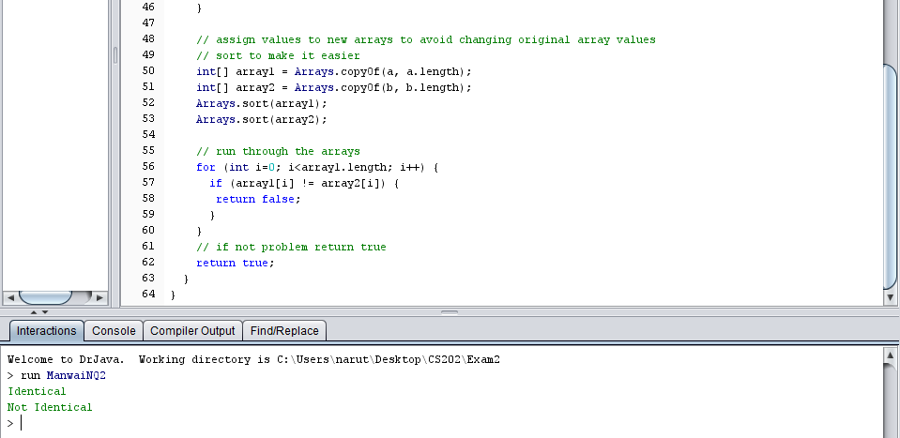

1. (20%) Do Programming Exercises P7.13 on page 356.

Write a method called “findAverage” to calculate the average (with 5 floating-point digits) of ten floating-point values in the “input.txt” file.

Then use the main method to call the findAverage method and pass “input.txt” to it.

The findAverage method returns the output.txt (includes the original floating-point values and the average in the bottom line) to main method.

Assume the input.txt file contains the following ten numbers:

3.14159 2.71828 5.30628 7.21089 4.29178 6.31904 7.20495 1.40294 9.42846 8.36081

Use the following command line to test your program:

> java JohnSQ3 input.txt output.txt

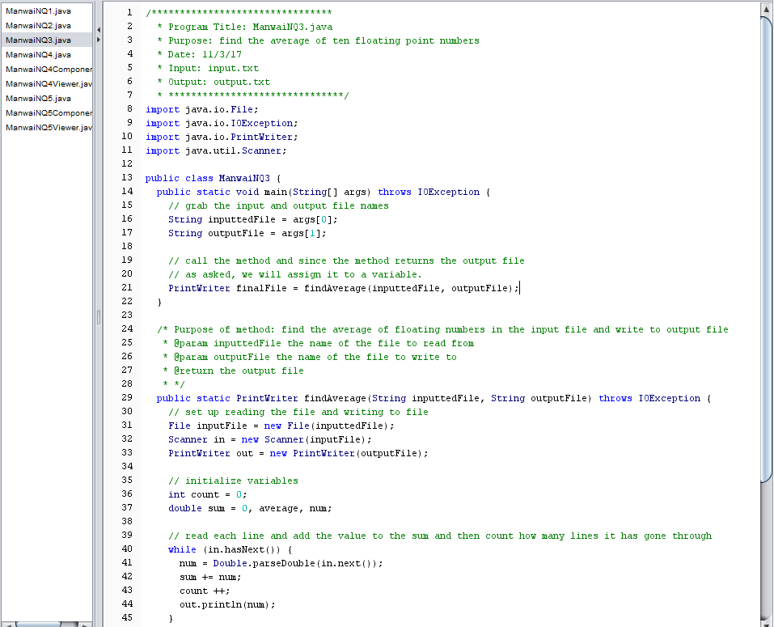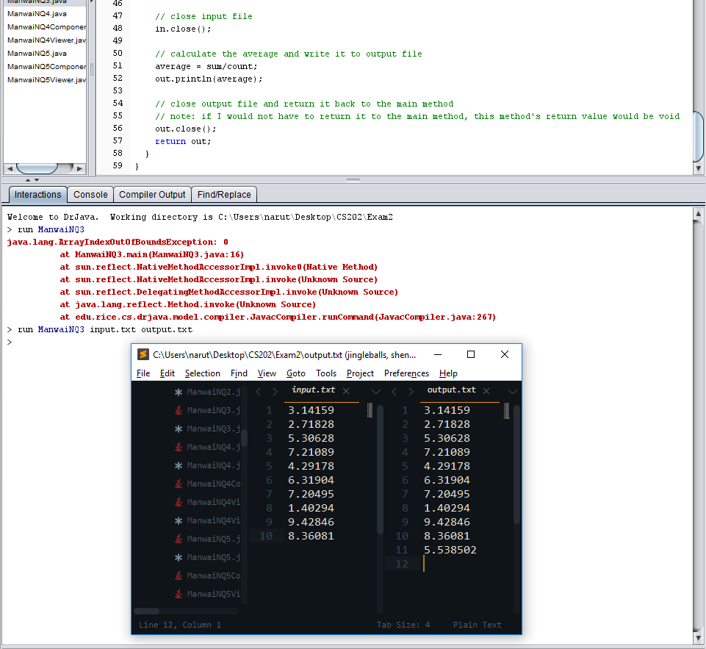

1. 4. (20%) Do Programming Exercises P10.13 on page 503.

4.1 Provide three labels, Initial Deposit, Interest Rate, and Years, to allow user to enter initial deposit, interest rate and years of balance to calculate.

4.2 Print the balance (e.g. $1,304.63) follow by the bar chart (i.e. the filled rectangle) for each year.

4.3 Set the color of the filled rectangle to a beautiful one.

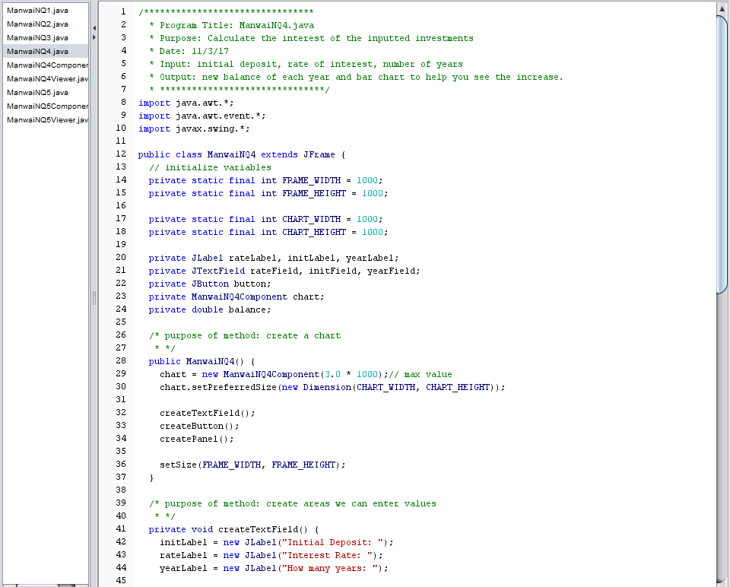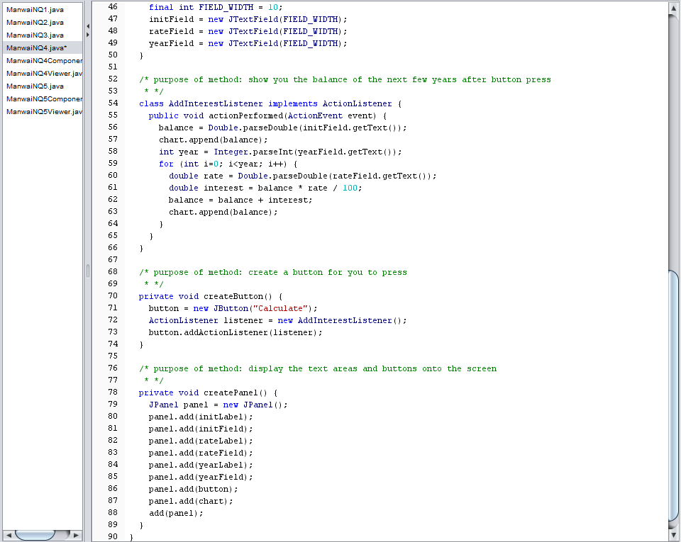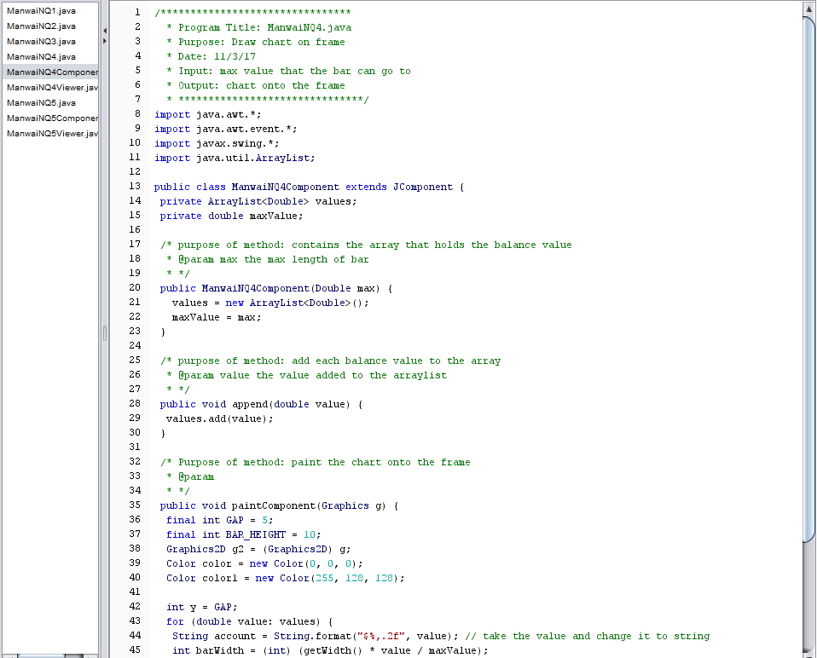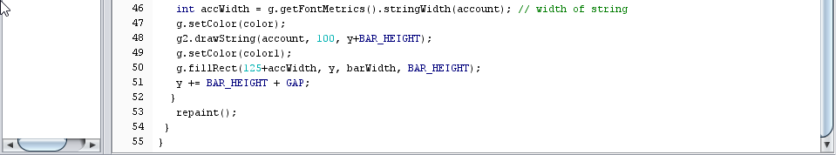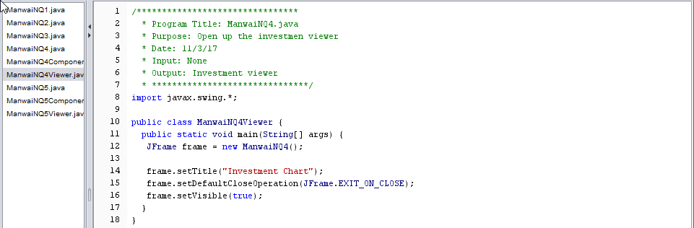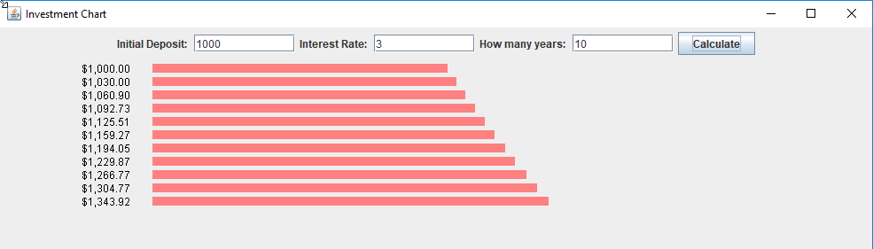

1. (20%) Do Programming Exercises P10.31 on page 505.

5.1 Use different colors and line widths to draw the clock frame, clock numbers (i.e. 1 to 12) and the hour and minute needles.

5.2 When user enters hour and minute (e.g. 13:45), your program have to use an equation to calculate the exact moving angles on the clock face (e.g. 112.5 degrees for the hour needle and 270 degrees for the minute needle if user enters 13:45) of the hour and minute needles.

